

Prepared by

Name of the entity producing the document   
*(Use of company logo permitted, but no larger than ODOT’s)*

Submitted to: *Name of the Division/District or Office*

Date *(month & Year)*

**Mapping Survey Quality Control Report**

**Location Information (CRS)**   
PID XXXXX



Contents

Purpose 2

Project Summary 2

Scope of Data Collection 2

Datum and Coordinate System 3

Project Accuracy 4

DTM Accuracy Statement 4

Horizontal Planimetric Accuracy Statement 4

Surveyor’s Certification Statement 4

Project Team 5

Project Notes 6

DTM Notes 6

Horizontal Planimetric Notes 6

Orthophoto Notes 6

Mapping Control/ Check Point Notes 6

Miscellaneous Notes 6

*Vertical Accuracy Statistic Worksheet* 7

Vertical Accuracy Statistic Worksheet (NVA and VVA) 8

*Horizontal* Accuracy Statistic Worksheet 11

Horizontal Accuracy Statistic Worksheet 12

Project Summary

## Purpose

The purpose of this document is to provide the recipient of the data necessary background information to make actionable decisions in use and applicability of the provided data. This includes overall Mapping Survey procedures and accuracy calculations made in adherence to the Ohio Department of Transportation Survey and Mapping Specifications.

## Project Summary

### Scope of Data Collection

*In this section provide a description of the intent and overall scope of the project. This section can include a project limits map (vicinity map), and general comments as to the background of the data utilized in generating deliverables.*

*Example*

*Data provided for PID XXXXX was compiled for engineering design use. The DTM utilizes a project specific aerial LiDAR dataset and is supplemented outside the boundary with state-wide LiDAR data collected in the OSIP III data collection. Supplemental ground topo was not collected in the generation of the DTM. The 2D planimetrics were compiled using stereo compilation and flattened to two dimensions when delivered. Orthophotos were collected with a project specific data collection, which was also used in the stereo compilation, and orthorectified using a combination of project specific LiDAR and OSIP III data for relief distortion removal.*

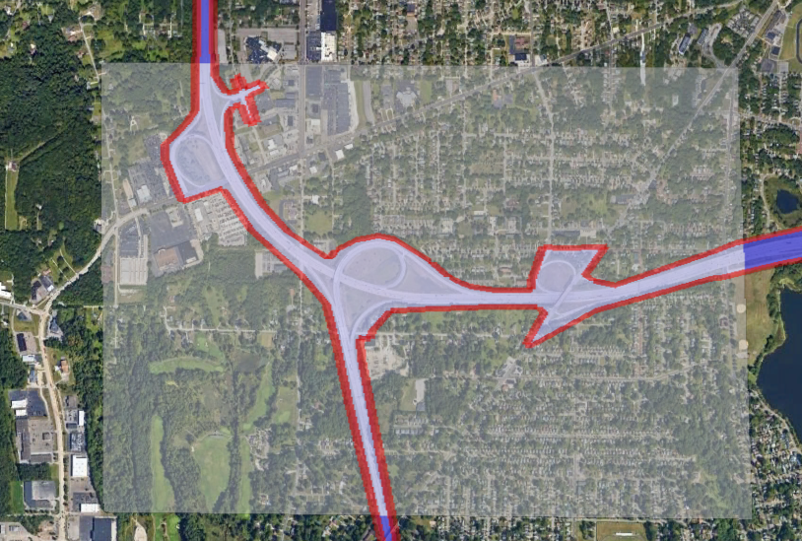

*Figure 1 Areas shaded in white utilize OSIP III while data inside red boundary was collected at project level*

### Datum and Coordinate System

All final deliverables provided are using the following Datums and Coordinate Systems.

#### Vertical

Orthometric Height Datum: *NAVD88*

Geoid Model: *GEOID18*

#### Horizontal

Coordinate System: *Ohio State Plane, (North, South) Zone*

Map Projection: *Lambert Conformal Conic*

Reference Frame: *NAD83 (2011)*

Ellipsoid: *GRS80*

Combined Scale Factor: *1.0000000000*

Project Adjustment Factor: *1.0000000000*

#### Units

All units for delivered files and data are using the US Survey Foot.

#### Data Collection Date(s)

Data was collected on Insert Date(s) Here and only represents the existing conditions of the project site at that time.

*User can incorporate a map/list denoting multiple flight dates and the areas they captured.*

## Project Accuracy

### DTM Accuracy Statement

This data set was tested to meet ASPRS Positional Accuracy Standards for Digital Geospatial Data (2014) for an Ohio Department of Transportation *Insert Vertical Accuracy Class Label* (US ft.) RMSEZ Vertical Accuracy Class. Actual NVA accuracy was found to be RMSEZ = ___ US ft., equating to +/- ___ US ft. at 95% confidence level. Actual VVA accuracy was found to be +/- ___ US ft. at the 95th percentile.

### Horizontal Planimetric Accuracy Statement

This data set was tested to meet ASPRS Positional Accuracy Standards for Digital Geospatial Data (2014) for an Ohio Department of Transportation 0.21 (US ft.) RMSEX / RMSEY Horizontal Accuracy Class. Actual positional accuracy was found to be RMSEX = ___ (US ft.) and RMSEY = ___ (US ft.) which equates to Positional Horizontal Accuracy = +/- ___ US ft. at 95% confidence level.

### Surveyor’s Certification Statement

I, (*Surveyor’s Name*) do hereby certify that the (Geodetic and/or Primary Project Control depending on project path) for (name of project) was constructed and established in accordance with the Ohio Department of Transportation’s Survey and Mapping Specifications, dated (last revision date) for a (Path 1 thru 5) project and meet the accuracy requirements as set forth by these specifications. (*For Conventional Mapping add this statement*) I also certify that all mapping data collected was conventionally surveyed using means and methods that meet the horizontal and vertical accuracies as set forth in the Survey and Mapping Specifications. (For INS Mapping Surveys add this statement) I also certify that all ground control points to control INS based Mapping Surveys have been set and meet the accuracy requirements as set forth in the Survey and Mapping Specifications (if applicable), also the Digital Terrain model generated by INS mapping has been checked and verified as to its horizontal and vertical accuracies as set forth in the Survey and Mapping Specifications. All observation data and RMSE calculations are included in my survey report and are made available to the Ohio Department of Transportation.

__________________________ _________________________

Signature Date

Surveyor’s Seal

Surveyor’s Printed Name

Registration Number

## Project Team

This section outlines the parties responsible for completing these different aspects of the Mapping Survey.

Project Control Completed by:

*District # Survey Staff (Example)*

Report Submitted by:

*CADD and Mapping Services Staff (Example)*

Mapping Performed by:

*CADD and Mapping Services Staff (Example)*

Mapping Checked by:

*CADD and Mapping Services Staff (Example)*

Conventional Mapping Survey Performed by *(if applicable)*:

*Consultant Name Survey Staff (Example)*

Mapping Deliverables Aggregated by *(if applicable)*:

*Consultant Name Survey Staff (Example)*

## Project Notes

This section describes any additional project related information relevant to the future use of the data.

### DTM Notes

*Example:*

* *All subsurface drainage, ditch inverts, or channel inverts require field collection and inclusion into the furnished existing surface model.*
* *Areas with dense brush or heavy vegetation require field collection and inclusion into the existing surface model.*
* *Retaining walls and bridges require field collection and inclusion into the existing surface model.*
* *Voids were created for areas of low confidence*

### Horizontal Planimetric Notes

*Example:*

* *Paint lines were not collected within this dataset*
* *Only features visible from the air were collected*
  + *All subsurface utilities require field collection*

### Orthophoto Notes

*Example:*

* *OSIP data was used to supplement outside of project limits in processing*
* *.TFW files are required to utilize georeferenced imagery in native project coordinate system*

### Mapping Control/ Check Point Notes

*Example:*

* *All mapping control was collected using primary project control using a total station.*

### Miscellaneous Notes

*Example:*

* *All mapping control was collected using primary project control using a total station.*

# *Vertical Accuracy Statistic Worksheet*

### Vertical Accuracy Statistic Worksheet (NVA and VVA)

Data provided in this section was used to calculate the Non-Vegetated Vertical Accuracy (NVA) and the Vegetated Vertical Accuracy (VVA). This worksheet was created from the FGDC National Standard for Spatial Data Accuracy (NSSDA) Vertical Accuracy Calculation Spreadsheet (<https://www.fgdc.gov/standards/projects/accuracy/part3>) for assistance in calculating the positional accuracy standards. Software which recognizes the ASPRS Positional Accuracy Standards for Digital Geospatial Data may be supplemented in this area, all check points are required to be included within the following tables.

A version of this spreadsheet can be found here (**NEED LINK**) to aid in the calculations. Separate spreadsheets should be utilized to calculate the NVA and VVA. Additional rows may be added/inserted for larger projects. Please see the Ohio Department of Transportation Survey and Mapping Specifications for check point quantities and locations.

Table NVA check Point Table

|  |  |  |  |  |
| --- | --- | --- | --- | --- |
| **Survey Point Number** | **Survey Point Easting** | **Survey Point Northing** | **Survey Check Point Elevation (Independent)** | **DTM Elevation (Test)** |
|
|
|  |  |  |  |  |
|  |  |  |  |  |
|  |  |  |  |  |
|  |  |  |  |  |
|  |  |  |  |  |
|  |  |  |  |  |
|  |  |  |  |  |
|  |  |  |  |  |
|  |  |  |  |  |
|  |  |  |  |  |
|  |  |  |  |  |
|  |  |  |  |  |
|  |  |  |  |  |
|  |  |  |  |  |
|  |  |  |  |  |
|  |  |  |  |  |
|  |  |  |  |  |
|  |  |  |  |  |
|  |  |  |  |  |
|  |  |  |  |  |
|  |  |  |  |  |
|  |  |  |  |  |
|  |  |  |  |  |
|  |  |  |  |  |
|  |  |  |  |  |
|  |  |  |  |  |
|  |  |  |  |  |
|  |  |  |  |  |
|  |  |  |  |  |
|  |  |  |  |  |
|  |  |  |  |  |
|  |  |  |  |  |
|  |  |  |  |  |
|  |  |  |  |  |
|  |  |  |  |  |
|  |  |  |  |  |
|  |  |  |  |  |
|  |  |  |  |  |
|  |  |  |  |  |
|  |  |  |  |  |

Table VVA Check Point Table

|  |  |  |  |  |
| --- | --- | --- | --- | --- |
| **Survey Point Number** | **Survey Point Easting** | **Survey Point Northing** | **Survey Check Point Elevation (Independent)** | **DTM Elevation (Test)** |
|
|
|  |  |  |  |  |
|  |  |  |  |  |
|  |  |  |  |  |
|  |  |  |  |  |
|  |  |  |  |  |
|  |  |  |  |  |
|  |  |  |  |  |
|  |  |  |  |  |
|  |  |  |  |  |
|  |  |  |  |  |
|  |  |  |  |  |
|  |  |  |  |  |
|  |  |  |  |  |
|  |  |  |  |  |
|  |  |  |  |  |
|  |  |  |  |  |
|  |  |  |  |  |
|  |  |  |  |  |
|  |  |  |  |  |
|  |  |  |  |  |
|  |  |  |  |  |
|  |  |  |  |  |
|  |  |  |  |  |
|  |  |  |  |  |
|  |  |  |  |  |
|  |  |  |  |  |
|  |  |  |  |  |
|  |  |  |  |  |
|  |  |  |  |  |
|  |  |  |  |  |
|  |  |  |  |  |
|  |  |  |  |  |
|  |  |  |  |  |
|  |  |  |  |  |
|  |  |  |  |  |
|  |  |  |  |  |
|  |  |  |  |  |
|  |  |  |  |  |
|  |  |  |  |  |
|  |  |  |  |  |

# *Horizontal* Accuracy Statistic Worksheet

### Horizontal Accuracy Statistic Worksheet

Data provided in this section was used to calculate the Horizontal Planimetric Accuracy. This worksheet was created from the FGDC National Standard for Spatial Data Accuracy (NSSDA) Horizontal Accuracy Calculation Spreadsheet (<https://www.fgdc.gov/standards/projects/accuracy/part3>) for assistance in calculating the positional accuracy standards. Software which recognizes the ASPRS Positional Accuracy Standards for Digital Geospatial Data may be supplemented in this area, all check points are required to be included within the following tables.

A version of this spreadsheet can also be found here (**NEED LINK**). Additional rows may be added/inserted for larger projects. Please see the Ohio Department of Transportation Survey and Mapping Specifications for check point quantities and locations.

Table Horizontal check Point Table

|  |  |  |  |  |  |
| --- | --- | --- | --- | --- | --- |
| **Survey Point Number** | **Survey Point Description** | **Survey Check Point Easting (Independent)** | **Mapping Derived Easting (Test)** | **Survey Check Point Northing (Independent)** | **Mapping Derived Northing (Test)** |
|
|
|  |  |  |  |  |  |
|  |  |  |  |  |  |
|  |  |  |  |  |  |
|  |  |  |  |  |  |
|  |  |  |  |  |  |
|  |  |  |  |  |  |
|  |  |  |  |  |  |
|  |  |  |  |  |  |
|  |  |  |  |  |  |
|  |  |  |  |  |  |
|  |  |  |  |  |  |
|  |  |  |  |  |  |
|  |  |  |  |  |  |
|  |  |  |  |  |  |
|  |  |  |  |  |  |
|  |  |  |  |  |  |
|  |  |  |  |  |  |
|  |  |  |  |  |  |
|  |  |  |  |  |  |
|  |  |  |  |  |  |
|  |  |  |  |  |  |
|  |  |  |  |  |  |
|  |  |  |  |  |  |
|  |  |  |  |  |  |
|  |  |  |  |  |  |
|  |  |  |  |  |  |
|  |  |  |  |  |  |
|  |  |  |  |  |  |
|  |  |  |  |  |  |
|  |  |  |  |  |  |
|  |  |  |  |  |  |
|  |  |  |  |  |  |
|  |  |  |  |  |  |
|  |  |  |  |  |  |
|  |  |  |  |  |  |
|  |  |  |  |  |  |
|  |  |  |  |  |  |
|  |  |  |  |  |  |
|  |  |  |  |  |  |
|  |  |  |  |  |  |